Selasa, 28 Juni 2022

** Dimas Dwi Putra *51418957***

**Database**

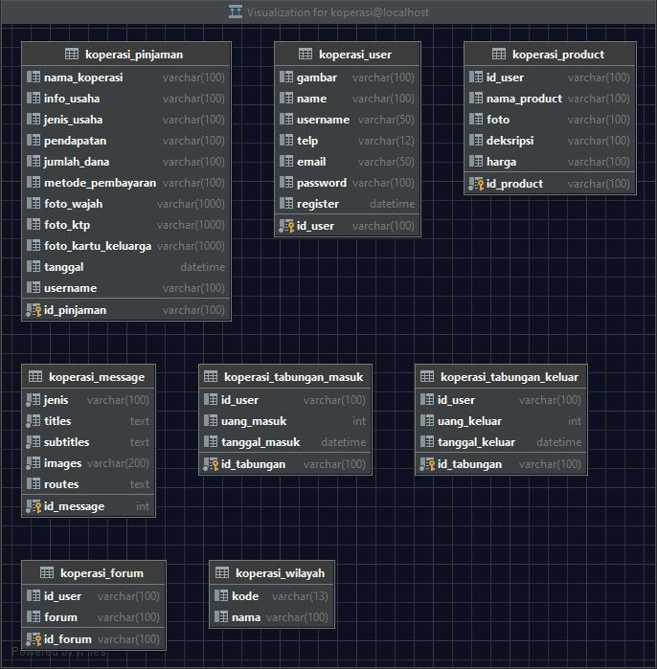

**Halaman Welcome**

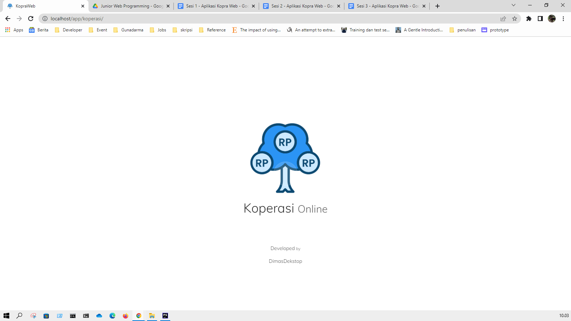

**Login**

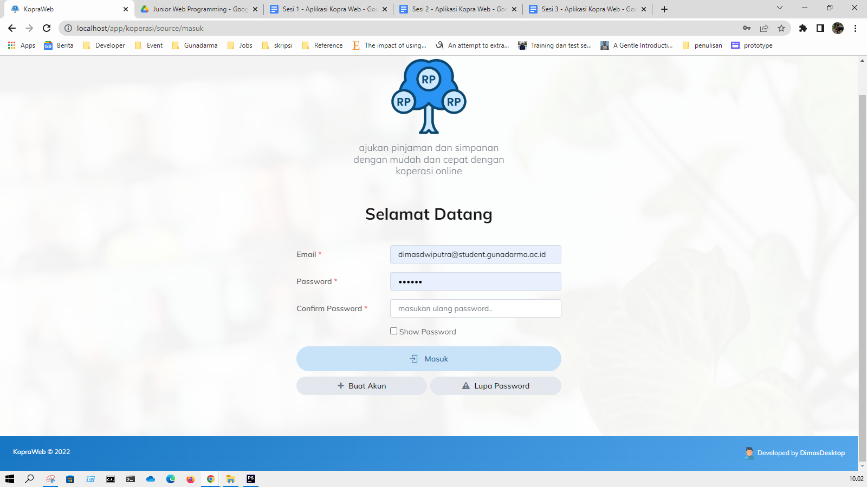

**Dashboard**

